The following items are for sale.

Please contact Stacy at rosseter@hotmail.com for information.
No reasonable offer will be refused.

Bill KI4zmv

MFJ 941E Versa Tuner

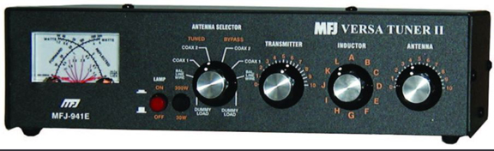
MFJ 989C Versa Tuner

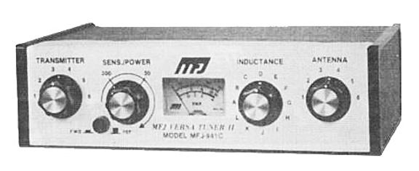
Drake L75 wide range linear amplifier

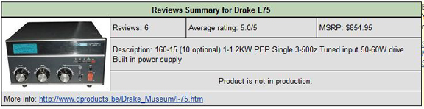

Drake TR7 Transceiver

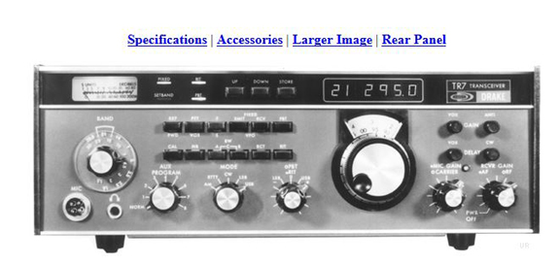
CDE Direction Control

And finally, a rather tall tower. No other description available.

Again, for more information contact Stacy, rosseter@hotmail.com

